ASSIGNMENT 1- SMART HOME USING IOT

TEAM ID:PNT2022TMID01082
DONE BY: A.PREM KUMAR(211419106205)
[TEAM MEMBER: 1]
CIRCUIT DIAGRAM

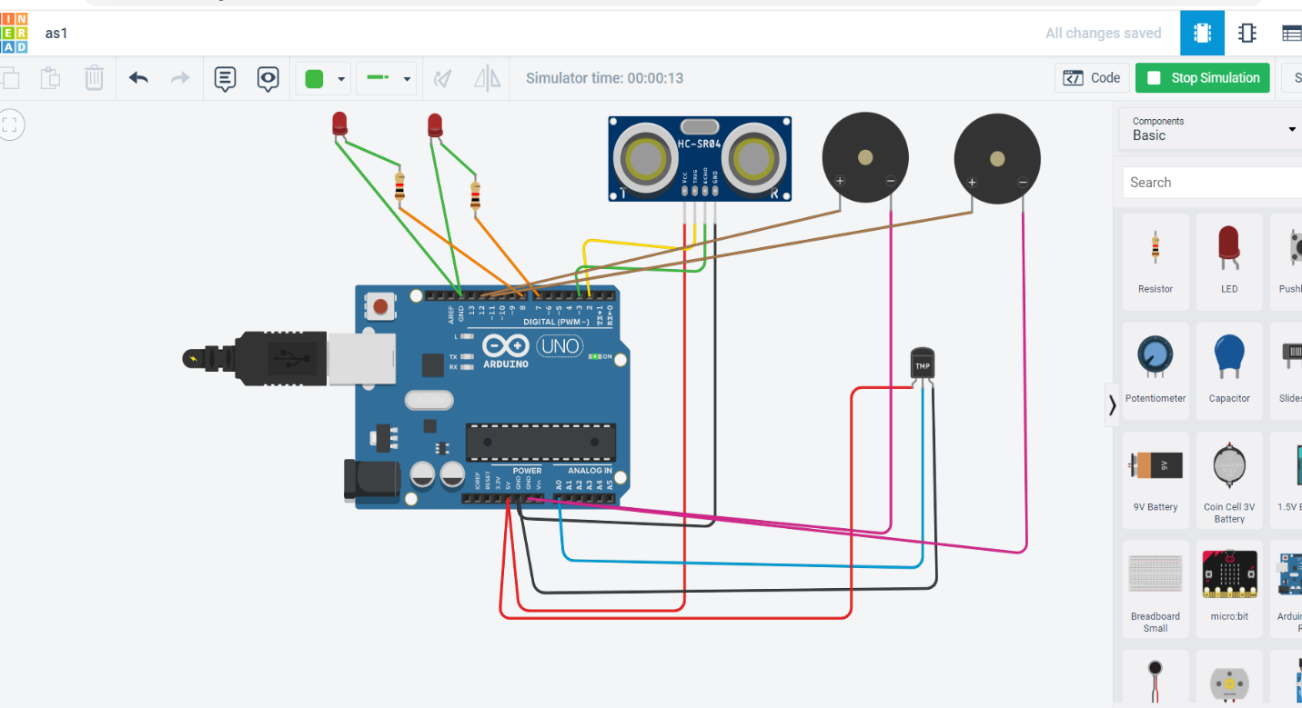

SOURCE CODE
int
t=2;
int e=3;
void setup()
{
Serial.begin(9600);
pinMode(t,OUTPUT);
pinMode(e,INPUT);
pinMode(12,OUTPUT);
}
void loop()
{
//ultrasonic sensor
digitalWrite(t,LOW);
digitalWrite(t,HIGH);
delayMicroseconds(10);
digitalWrite(t,LOW);
float dur=pulseIn(e,HIGH);

float dis=(dur*0.0343)/2;
Serial.print("Distance is: ");
Serial.println(dis);
//LED ON
if(dis>=100)
{
digitalWrite(8,HIGH);
digitalWrite(7,HIGH);
}
//Buzzer For ultrasonic Sensor
if(dis>=100)
{
for(int i=0; i<=30000; i=i+10)
{
tone(12,i);
delay(1000);
noTone(12);
delay(1000);
}
}

//Temperate Sensor
int a= analogRead(A0);
int t=(((a/1024)*5)-0.5)*100;
Serial.print("Temp Value: ");
Serial.println(t);
delay(1000);

//LED ON
if(t>=100)
{

digitalWrite(8,HIGH);
digitalWrite(7,HIGH);
}
//Buzzer for Temperature Sensor
if(t>=100)
{
for(int i=0; i<=30000; i=i+10)
{
tone(12,i);
delay(1000);
noTone(12);
delay(1000);
}
}
//LED OFF
if(t<100)
{
digitalWrite(8,LOW);
digitalWrite(7,LOW);
}
}

